St Asaph Flood Risk Management Scheme (FRMS)

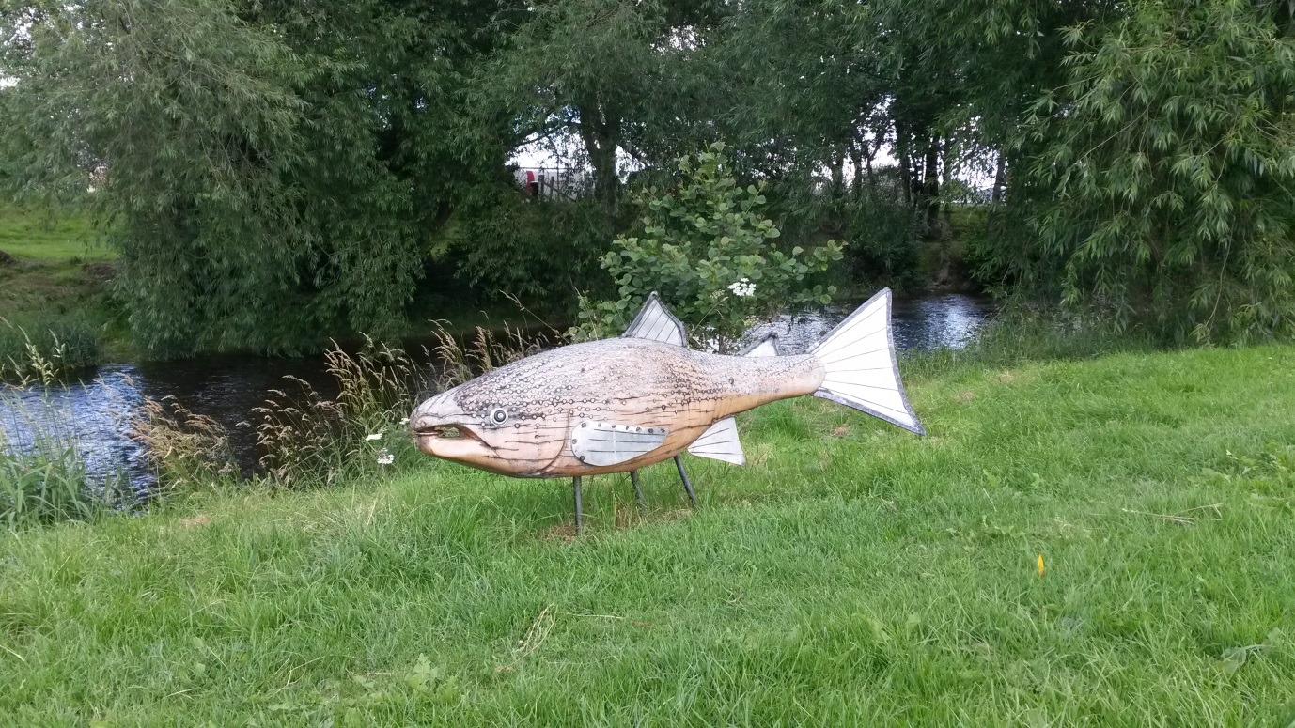

Environmental Assessment Summary

Environmental Assessment Team

Rev No P01

# CONTENTS

1.0 Introduction 3

2.0 Background to the Scheme 4

3.0 The Study Area 8

4.0 Reaching the Preferred Option 13

5.0 Environmental Assessment Summary 20

6.0 Conclusions 32

# 1.0 Introduction

This report is the non-statutory environmental assessment of St Asaph Flood Risk Management Scheme (FRMS). The report provides a summary of the environmental assessment work undertaken to aid the selection of the preferred option and guide the subsequent design of the Scheme.

Natural Resources Wales (NRW) has a duty under the Environment (Wales) Act 2016 to apply the principles of sustainable management of natural resources (SMNR) (Figure 1.1) through the exercise of our functions. This is a non-statutory environmental assessment, which allows us to transparently demonstrate the application of the principles of sustainable management of natural resources. The report draws together the wide range of evidence and assessments that have been undertaken in appraising and selecting the preferred option and in reaching the final design. It presents them in a format for stakeholder consultation.

## Figure 1.1 Principles of Sustainable Management of Natural Resources

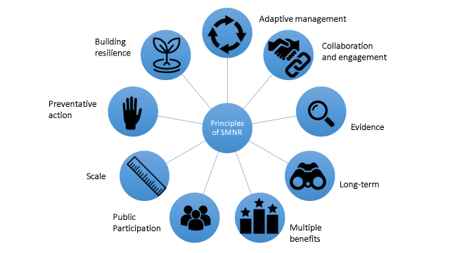

This report documents the key environmental risks and opportunities and signposts the reader to the detailed reports that support decision making. In this way the report can be kept succinct but refers the reader to specialist areas that may be of particular concern or interest.

Further information is contained on the Scheme website [*https://naturalresources.wales/about-us/our-projects/st-asaph-flood-scheme/?lang=en*](https://naturalresources.wales/about-us/our-projects/st-asaph-flood-scheme/?lang=en)

Or from the Environmental lead for the Scheme:

Marianne Jones

Senior Environmental Project Manager

Natural Resources Wales

[Marianne.Jones@cyfoethnaturiolcymru.gov.uk](mailto:Marianne.Jones@cyfoethnaturiolcymru.gov.uk)

If you wish to receive this document in Welsh, please contact us.

# 2.0 Background to the Scheme

## Drivers for the Scheme

The River Elwy has flooded St Asaph on a number of occasions. During the 20th century, flooding was reported during 1964 and 1965. This prompted construction of the original defences through the city. These defences were raised again during 1975. During November 2012, the defences were overwhelmed when prolonged heavy rainfall caused the Elwy to rise to 3m above its normal level and flooded over 300 properties (residential and commercial) and 70 caravans within the city; see Figures 2.1 and 2.2 below.

## Figure 2.1: November 2012 Flooding at St Asaph

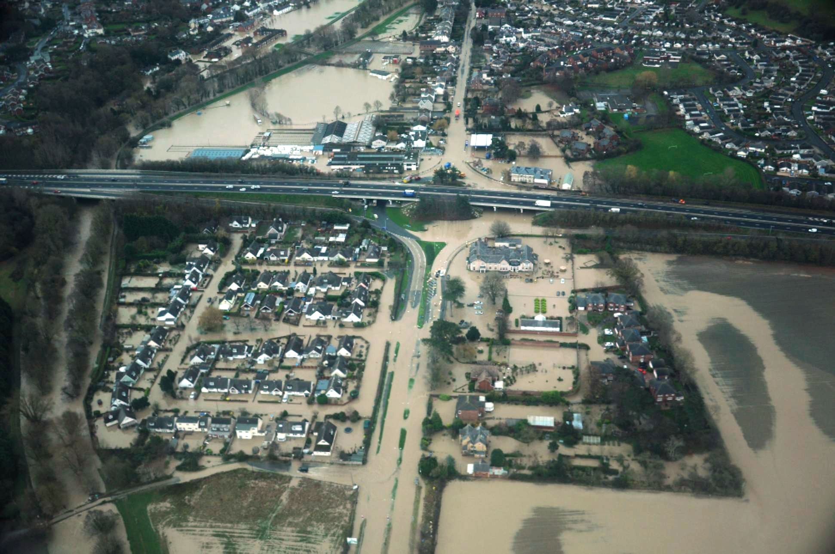

The November 2012 flood was estimated to have had between a 1 in 100 (1%) and 1 in 200 (0.5%) chance of occurring in any given year. Overtopping of the defences during November 2012 gave rise to severe flood damages throughout the city. The reported flood extent for the event in St Asaph is presented in Figure 2.2 below.

## Figure 2.2: November 2012 Flood Extent at St Asaph

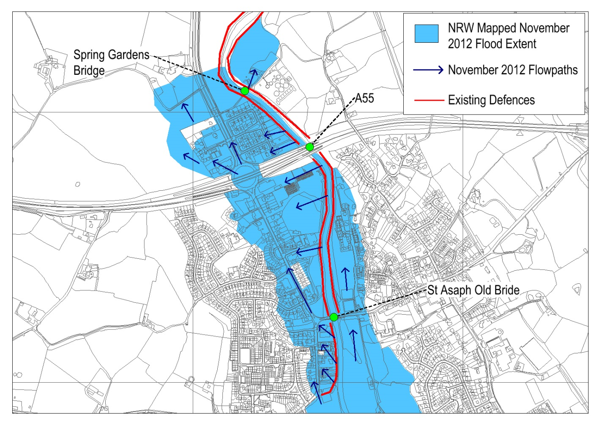

**St Asaph Old Bridge**

© Crown copyright and database rights 2016 Ordnance Survey 100019741

© Hawlfraint y Goron a hawliau cronfa ddata 2016 Arolwg Ordnans 100019741

## Level of Flood Risk

Flood modelling undertaken for the *St Asaph FRMS Project Appraisal Report (PAR)*[1] showed that there are around 430 properties in St Asaph at risk from a flood with a 1 in 200 (0.5%) chance of occurrence in any given year. This includes 293 homes and 135 businesses, together with locally important highway infrastructure.

The existing defences would be overtopped by a flood with a 2% (1 in 50) chance of occurrence in any given year.

The defences are generally in a reasonable condition however some sections, notably a section from Lower Denbigh Road to St Asaph Old Bridge are in a relatively poor condition. Private gardens have encroached over parts of the defence, limiting access to maintain it. To date, NRW have been reliant on private landowners mowing the embankment to prevent heavy stands of vegetation establishing, which might compromise its integrity.

Climate change is predicted to increase the frequency with which severe floods occur in St Asaph. Future climate change will both significantly reduce the standard of protection provided by the existing defences and increase the number of properties at risk from flooding. If the defences remain at their present height, by 2070, the consequences for St Asaph would be:

* The city’s defences would only provide around a 6.7% (1 in 15) annual chance standard; and
* Some 520 residential and 180 commercial properties would be at risk in the 0.5% (1 in 200) annual chance flood.

It was concluded in the St Asaph FRMS PAR that a Scheme is required to reduce both the present risk of flooding in St Asaph and to allow for it to be managed for the effects of future climate change.

## Scheme Objectives

The Scheme objective is to provide St Asaph with improved flood defences that protect the city against a flood with a present day 0.5% (1 in 200) chance of occurrence in any given year. Future climate change will reduce the standard of protection provided by the defences. The defences are designed so they can be raised again the future to maintain a 1% (1 in 100) annual chance standard of flood protection to St Asaph.

The Scheme should also ensure no net increase in flood risk (detriment) to properties located up- and downstream of St Asaph.

In addition to providing a reduction in flood risk, the Scheme has identified opportunities to deliver wider environmental and community benefits including:

* Setting-back defences, where practicable, to improve the appearance of St Asaph Old Bridge, which is a Grade II Listed Building and Schedule Ancient Monument (SAM).
* Providing access improvements by widening and/or resurfacing existing foot and cycle paths which are linked to the existing flood defences.
* Providing environmental enhancements to the Scheme area and wider catchment, including provision of bird/bat boxes, addition of wild flower seed mix to embankment cover, contribution towards local sculpture, provision of dual waste/litter bins, tree and hedgerow planting including planting of native black poplars and community orchard, and provision of interpretation board for St Asaph Old Bridge SAM in collaboration with Cadw.

## Screening and Environmental Requirements

An Environmental Impact Assessment (EIA) Screening Assessment has been undertaken for the St Asaph FRMS which concluded that the Scheme will not give rise to significant environmental effects. Denbighshire County Council (DCC) provided a formal screening opinion for the St Asaph FRMS, dated 13th October 2015, indicating that:

*‘It is the opinion of the Council that the proposed development:*

*is not considered to be a major development of more than local importance;*

*is not proposed within an environmentally sensitive or vulnerable location;*

*is not likely to give rise to particularly complex and potentially hazardous effects;*

*is not likely to have significant effects on the environment by virtue of factors such as its nature, size and location.*

*Consequently the proposed development is not Environmental Impact Assessment development requiring the submission of an Environmental Statement.’*

Opinions were also sought from NRWs’ protected sites and marine licencing teams who confirmed that no assessment under the Habitat Directive or Marine Consent would be required respectively.

It is anticipated that the Scheme will require the following consents:

* Planning Consent under the Town and Country Planning Act, 1990.
* Flood Defence Consent for both temporary and permanent works under the Water Resources Act 1991 and applicable NRW bylaws.
* Listed Building Consent for works which tie into St Asaph Old Bridge.
* Consent for the demolition of boundary walls within the Conservation Area.
* Scheduled Monument Consent for works under the St Asaph Old Bridge arches, from Cadw.
* Section 38 Consent for development within St Asaph Common Land, from Welsh Assembly Government.

# 3.0 The Study Area

The full study area for the *St Asaph FRMS PAR[2]* extended along the River Elwy from properties at Wigfair Isaf in the south to Rhuddlan in the north; refer to Figure 3.1. This area was determined to ensure that all properties and land which could be affected by a Scheme to reduce the flood risk to properties in St Asaph could be considered.

It is noted that the Elwy catchment upstream of St Asaph is a trial catchment for the implementation of Natural Flood Risk Management (NFRM) techniques. NRW undertook the Elwy Natural Flood Risk Management and Ecosystems Services Study (AECOM 2014) which showed that implementation of a range of NFRM measures within the Elwy catchment could deliver a small reduction in flood risk through St Asaph. Consideration was given during the St Asaph FRMS development to include of some of the measures proposed by the NFRM study. Priority has been given however to funding environmental enhancements within the immediate Scheme area with the anticipation of NFRM measures being undertaken via separate funding in the future.

Following the *St Asaph FRMS PAR,* the study area for the St Asaph FRMS was focussed in on the Scheme footprint and working areas along the River Elwy through St Asaph; extending from Lower Denbigh Road through to Spring Gardens. Works at two locations downstream of the city, namely Dol Afon and Rhuddlan, are also considered to ensure no increase in flood risk downstream of the main Scheme. Figure 3.2 and Table 3.1 outline the specific Scheme extents considered in this report.

Some specialist topic areas, e.g. ecology or landscape, have wider or smaller study areas; these are described within the relevant assessment reports.

## Table 3.1 – St Asaph FRMS Scheme Extent Grid Locations

|  |  |  |  |  |
| --- | --- | --- | --- | --- |
| **Element** | **Upstream Extent** | | **Downstream Extent** | |
| **NGR** | **Location** | **NGR** | **Location** |
| St Asaph Main Scheme | SJ 0350 7379 | Lower Denbigh Road | SJ 0224 7534 | Spring Gardens |
| Downstream Mitigation | SJ 0324 7593 | Dol Afon | SJ 0320 7608 | Dol Afon |
| Downstream Mitigation | SJ 0210 7784 | Station Road, Rhuddlan | SJ 0215 7793 | Station Road, Rhuddlan |

## Figure 3.1 – St Asaph FRMS PAR Study Area

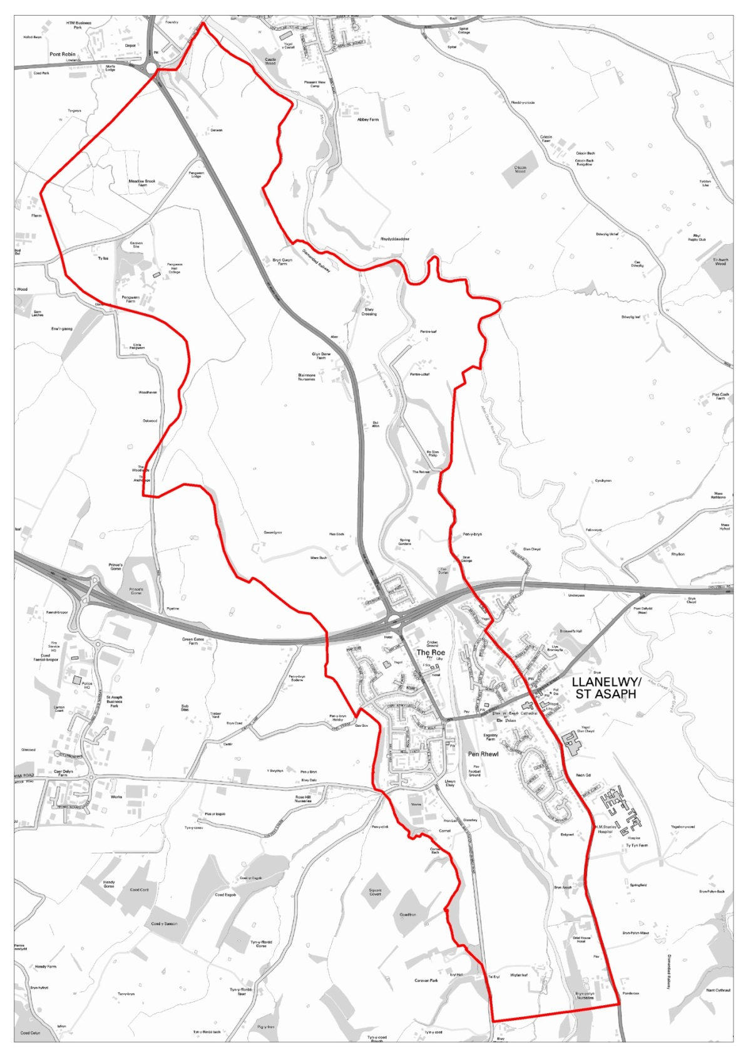

© Crown copyright and database rights 2016 Ordnance Survey 100019741

© Hawlfraint y Goron a hawliau cronfa ddata 2016 Arolwg Ordnans 100019741

## Figure 3.2 – St Asaph FRMS Scheme Extent (denoted by red line)

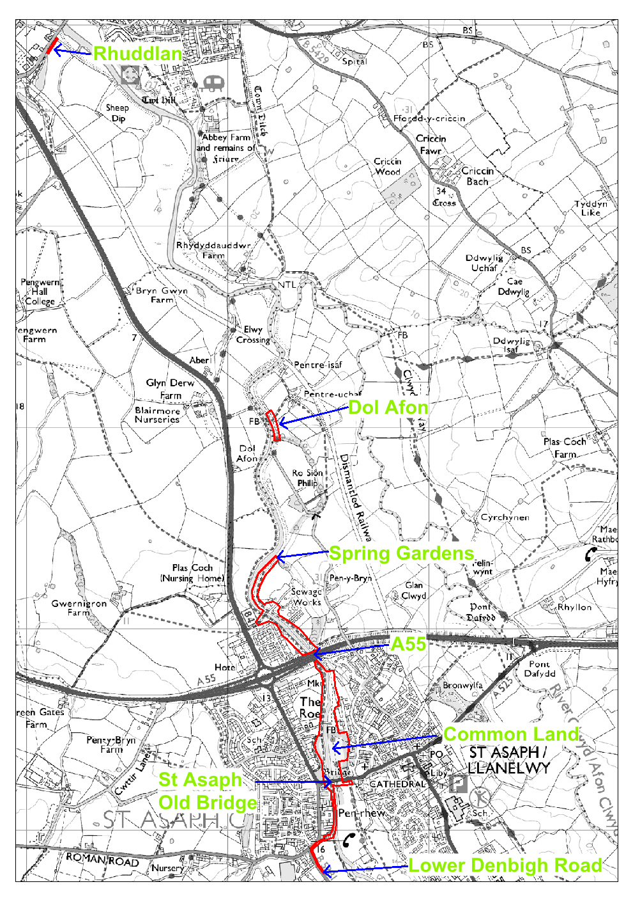

© Crown copyright and database rights 2016 Ordnance Survey 100019741

© Hawlfraint y Goron a hawliau cronfa ddata 2016 Arolwg Ordnans 100019741

## Scheme Area Constraints

Constraints plans for the Scheme extent are provided in Appendix A. Of particular note are:

The St Asaph Conservation Area (refer to Constraints Plans);

St Asaph Common Land (refer to Figure 3.2, Constraints Plans and Plates 1 and 2)

St Asaph Old Bridge with is Grade II Listed and a SAM (refer to Figure 3.2 and Plate 1).

The River Elwy is characterised by tree lined banks which form an important landscape and habitat feature (refer to Plate 3).

|  |  |
| --- | --- |
|  | Plate 1 – St Asaph Old Bridge |
|  | Plate 2 – St Asaph Common and Sustrans Cycling Route along flood embankment crest |
|  | Plate 3 – Information Board depicting biodiversity features along the River Elwy in St Asaph |

# 4.0 Reaching the Preferred Option

The preferred option was determined as part of the *St Asaph FRMS PAR*. This included long and short list assessments of potential options to identify a preferred approach. An outline of this process is provided below.

Long List Assessment

A long list of options to reduce flood risk to St Asaph was formed for the *St Asaph FRMS PAR*. The long list, together with a brief description of each option, is presented in Table 4.1 below.

## Table 4.1: Options Long List

|  |  |
| --- | --- |
| **Option Reference** | **Description** |
| Do Nothing (DN) | * ‘Walkaway’ option comprising a cessation of all maintenance, repairs, improvements, flood warnings and emergency response activities |
| Do Minimum (DM) | * ‘Existing conditions’ option where defences continue to be maintained to their current standard and are replaced when their condition degrades * Flood warnings continue to be given |
| L.1 | * Existing defences are raised and/or replaced |
| L.2 | * Existing defences are raised and/or replaced * Spring Gardens Bridge is removed and replaced with a new bridge that does not impede in-channel flows |
| L.3 | * Existing defences are raised and/or replaced * Left-bank defences between Spring Gardens Bridge and Dol Afon are set-back to lower water levels at the bridge |
| L.4 | * Existing defences are raised and/or replaced * Left-bank defences between Spring Gardens Bridge and Dol Afon are set-back to lower water levels at the bridge * Spring Gardens Bridge is removed and replaced with a new bridge that does not impede in-channel flows |
| L.5 | * All in-channel and bankside vegetation is removed along the River Elwy from St Asaph to its confluence with the River Clwyd to improve channel conveyance |
| L.6 | * Upstream storage together with improvements to the flood defence through the city where required |

The options were assessed against the following criteria:

* **Technical** – does the option deliver an acceptable decrease in flood risk?
* **Environmental** – does the option give rise to any adverse or unacceptable environmental impacts?
* **Economic** – would the option attract sufficient funding so it could be delivered and maintained.

A summary of the long list option assessment is presented in Table 4.2 below.

## Table 4.2: Long List Assessment Summary

|  |  |  |  |  |  |  |  |
| --- | --- | --- | --- | --- | --- | --- | --- |
| **Long List Option Reference** | **Description** | | | **Appraisal** | | | **Taken Forward** |
| **Technical** | **Environmental** | **Economic** |
| L.1 | * Raise existing defences | | | **✓** | **U** | **✓** | **NO** |
| L.2 | * Raise existing defences * Replace Spring Gardens Bridge | | | **✓✓** | **✓** | **✓** | **YES** |
| L.3 | * Raise existing defences * Set-back downstream defence | | | **✓✓** | **U** | **🗶** | **NO** |
| L.4 | * Raise existing defences * Set-back downstream defence * Replace Spring Gardens Bridge | | | **✓✓** | **U** | **🗶** | **NO** |
| L.5 | * Clear all channel vegetation to improve conveyance | | | **🗶** | **🗶🗶** | **🗶** | **NO** |
| L.6 | * Upstream storage | | | **✓** | **🗶🗶** | **🗶🗶** | **NO** |
|  | | | | | | | |
| **✓✓** |  | **Option Viability** | Technically / Economically / Environmentally Feasible | | | | |
| **✓** |  | | | | |
| **U** | Neutral / no impact | | | | |
| **🗶** |  | | | | |
| **🗶🗶** | Not Technically Feasible / Too Expensive / Significant Adverse Environmental Impact | | | | |

Option L.1 was discounted as whilst it delivered a reduction in flood risk it required higher (and therefore more expensive) flood defences that Option L.2. Options L.3 to L.6 were discounted primarily on economic grounds.

Short List Assessment

Three of the options, namely Do Nothing, Do Minimum and L.2, were taken forward to the short list assessment and subject to a more detailed appraisal. Six variations of Option L.2 were considered at the short list stage to determine the preferred standard of flood protection (either 1 in 100 (1%) or 1 in 200 (0.5%) annual chance) and approach to adapt the defences for resilience against future climate change.

Providing a higher standard of flood protection or making a larger allowance for future climate change makes the options progressively more challenging to deliver. This is because it will require a higher and larger increase in the footprint of the defences. For a typical flood embankment, an increase in the flood defence level by 0.3m equates to a 2m increase in the footprint of the embankment. This significantly increases the amount of material required to build the bank, but, more pertinently, is increasingly challenging to deliver along a river corridor when space is limited.

Flood levels and extents for each short listed option were obtained using the River Elwy ISIS/Tuflow model. Economic analysis was undertaken for all of the short listed options and reported in the St Asaph Economics Benefit Report[3].

The preferred option was determined through consideration of the flood modelling results and economic assessment, as well as looking at the potential environmental acceptability of each short list variant.

## Preferred Option

The preferred option for the St Asaph FRM Scheme is to provide a present day 1 in 200 (0.5%) annual chance standard of flood protection with a freeboard allowance. Flood defence improvement works are also to be undertaken at Dol Afon and Rhuddlan to ensure no increase in flood risk downstream of the main Scheme works. The works are designed so they can be raised again in around 50-years for future climate change.

The managed adaptive approach will be applied to allow the defences to be raised for climate change to maintain a 1 in 100 (1%) annual chance standard of protection in the future. This means floodwall foundations are, for example, designed and built to accommodate future raising without the need for replacement.

The main Scheme elements/details are outlined, per section, within Table 4.3 below. A map of these Scheme elements is provided in Figure 4.1.

Whilst a single Scheme, the St Asaph FRMS is being delivered as two discrete packages of work:

1. Package A consists of works to replace Spring Gardens Bridge, which is located immediately downstream of St Asaph and impedes flow within the River Elwy.
2. Package B consists of work to provide new, and improve existing, flood defences throughout St Asaph to protect it from flooding from the River Elwy.

This report considers the whole Scheme, including Package A and B.

## Table 4.3: Summary of Scheme Elements for the Preferred Option

|  |  |  |
| --- | --- | --- |
| **Bank** | **Reach** | **Details** |
| **West** | Lower Denbigh Road | * 260m of 1m high reinforced concrete (RC) floodwall with stone cladding * New flow control structure on the Glascoed Stream/Tributary |
| New Inn | * Replace 50m of 1.8-2m high boundary wall and internal reinforcement of existing property wall |
| Ruby Terrace | * 185m of RC floodwall up to 1m high, with concrete cut off and stone or brick cladding, along the top of the existing flood embankment |
| Co-Op & BT | * 100m of sheet pile floodwall up to 2.4m high with stone cladding * Floodwall set-back at St Asaph Old Bridge to improve views of, and access to, the bridge (SAM and Listed Building). Replaces existing 1.3-3m high wall and lowers 300m2 of land on riverward side of new wall |
| Recreation Ground West to Cattle Market | * 600m of existing embankment raised by up to 0.6m and re-profiled * Tarmac path on embankment crest increased to 2.4m wide |
| Roe Park | * 200m of sheet pile floodwall along existing embankment alignment, with brick cladding, up to 1.8m high, on landward side (landward toe of embankment removed) * 2.4m wide tarmac track for maintenance and pedestrian access |
| **East** | Fountains Garage | * Kerb raising along High Street and repairs to boundary wall of Fountains Garage * 0.5m high flood gate across access to unnamed track from High Street (between Fountains Garage and bus stop shelter) |
| Bowling Green | * 60m of RC floodwall with stone cladding along the bowling green boundary |
| Recreation Ground East | * 220m of existing embankment raised by up to 0.5m and re-profiled |
| Mill Street | * 230m of RC floodwall with stone cladding along the embankment crest * New flood control structure to drain floodplain in the event of the defences overtopping |
| Sewage Works | * 275m of existing embankment raised by up to 0.5m and re-profiled * Existing conifers removed to accommodate increased embankment footprint and promote grass growth on the embankment slopes |
| Spring Gardens Caravan Park | * 320m of existing embankment downstream of bridge raised by 0.1-0.2m |
| Spring Gardens Bridge | * Replacement of Spring Gardens Bridge to provide increased clearance within the river channel. New bridge soffit some 1m higher than existing and the span is increased by around 5m * Note subject to Planning Application Ref. 46/2016/0576 |
| **Downstream Mitigation Works** | Pentre Isaf and Pentre Uchaf / Dol Afon | * 110m of existing embankment raised by up to 0.5m to ensure no increase in flood risk as a consequence of raising defences through St Asaph |
| Rhuddlan | * 60m of new 0.5m high flood embankment alongside Station Road to ensure no increase in flood risk as a consequence of raising defences through St Asaph |

## Figure 4.1: Map of Scheme Elements (not including downstream mitigation)

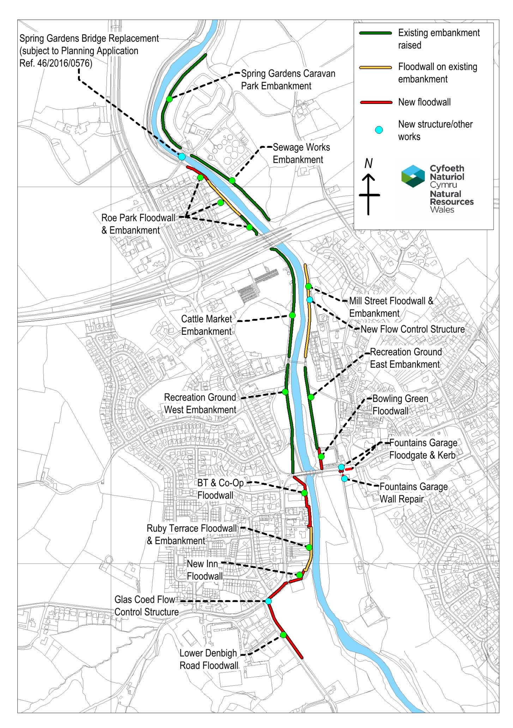

## Consultation

Two public consultation events have been held in St Asaph to inform the local community of the proposals and invite their comments upon the St Asaph FRMS.

1. The first of these events was held in the Oriel Hotel in St Asaph on 10th December 2014. This included a session of presentations by NRW and other collaborative parties to a group of key external stakeholders as well as a public open drop-in session during the afternoon and evening.
2. The second public consultation event was an open drop-in session held at the Roe Park meeting rooms in St Asaph on the 4th February 2016. This included an update on design progression since the previous event and details of the proposed Scheme.

In addition to consulting on the main Scheme, a separate public drop in session was held on 17th May 2016 to publicise and invite any comments and discussion on the Section 38 Common Land application, prior to this being submitted for all flood defence works proposed within St Asaph Common.

A stakeholder engagement plan was developed at for the *St Asaph FRMS PAR* and all key stakeholders and affected landowners have been engaged individually by NRW and their agents, as the Scheme has progressed through detailed design stage.

Key stakeholder groups consulted to date include:

* Affected landowners
* Afon Elwy Environmental group (AEEG)
* St Asaph City Council
* Clwyd and Powys Archaeological Trust (CPAT)
* Cadw
* DCC Archaeology, Conservation and Footpaths officers
* Rhyl and St Asaph anglers
* NRW Fisheries and Geomorphology teams
* NRW Biodiversity and Protected Sites teams
* Sustrans
* Service providers (BT, DCWW)

All feedback received from consultees and members of the public has been thoroughly considered and wherever possible the Scheme has been adapted to accommodate all reasonable requests and consideration given to any specific requirements of landowners or users. Some specific examples of this include:

* Re-design of the defences in the Cattle Market to retain the existing slurry tanks in their current location as requested by the owner;
* Resurfacing of a footpath between the A55 and Spring Gardens Bridge as proposed by Sustrans;
* Alignment of the Scheme’s enhancements with the Afon Elwy Environmental Group (AEEG) plans for the city; and
* Improve setting of St Asaph Old Bridge (which is a Listed Building and SAM) as requested by Cadw and DCC’s Conservation and Archaeological officers.

In addition to the public consultation events and individual landowner discussions, the local community has been updated on the development and progress of the St Asaph FRMS via NRW’s website and through regular updates from NRW to the St Asaph Flood Partnership.

Prior to the planning application for Package B being submitted, a period of 28 days consultation will be undertaken on the draft planning submission (including planning application and associated documents) in line with the Planning (Wales) Act 2015. Notices will be displayed on site and statutory consultees and affected landowners will be contacted at the start of this consultation, and documents will be provided via NRW’s website. A planning consultation report will be produced following this consultation, for submission with the planning application, documenting all consultation responses and how these have been addressed.

# 5.0 Environmental Assessment Summary

The following environmental studies and documents have been undertaken to inform the development of the Scheme:

* Water Framework Directive (WFD) Compliance Assessment
* Archaeological Desk Based Assessment
* Arboriculture surveys
* Bat roost surveys
* Great crested newt surveys
* Phase 1 Habitat survey (part of Preliminary Ecological Assessment)
* Indicative Landscape Plans / Constraints Plans
* Geotechnical Investigation (GI) Factual Report

An EIA Screening Assessment was undertaken for the *St Asaph FRMS PAR*. This concluded that the Scheme will not give rise to significant environmental effects. The following potential effects were considered within the screening assessment:

Flora and Fauna;

Cultural Heritage;

Landscape and Visual Amenity;

Human Beings; and

Land Use.

The potential environmental opportunities, impacts and constraints highlighted within the screening assessment have been further assessed taking account additional surveys and detailed consultation with key stakeholders and statutory bodies, e.g. Cadw.

The results of this environmental assessment are summarised within Table 5.1 below.

## Table 5.1: Environmental Assessment Summary Table.

| Topic: People / Human Population | | | | | |
| --- | --- | --- | --- | --- | --- |
| Baseline (including identification of environmental resources / constraints) | Potential Impact | Source of information | How has this been considered and/or mitigated?Opportunities for sustainable management of natural resources | Summary of consultation related to this issue | How will this be delivered? |
| Existing flood risk: Existing defences would be overtopped by a flood with a 2% (1 in 50) chance of occurrence in any given year.  Approximately 430 properties in St Asaph currently at risk from a flood with a 1 in 200 chance of occurrence in any given year (including 293 homes and 135 businesses and locally important highway infrastructure). | Reduction in flood risk within St Asaph (+ ve) | Flood modelling undertaken at Project Appraisal Report (PAR) stage | Previous flood events have informed detailed flood modelling. PAR undertaken to determine most appropriate Scheme and standard of protection.  Numerous positive social and health benefits to local residents who have been previously flooded and are concerned about a similar event to November 2012 occurring again.  Reduction in the cost of home insurance for protected properties which were previously at higher risk. | Public consultation undertaken in order to raise awareness of what the flood risk is, what work has been done to date (e.g. repairs and use of temporary flood defences), and what is being proposed through the Scheme.  Consultation with NRW Flood Risk and Operations teams on the design and Scheme components. | Through delivery of the Scheme.  Scheme will provide protection from flood events with a present day 1 in 200 (0.5%) annual chance of occurrence. |
| A number of residential properties are located in close proximity to the Scheme, and in some instances flood defences encroach onto property gardens and along property boundaries. | Temporary construction impacts (- ve) | Refer to constraints plans for detail | Construction impacts may include noise, vibration, dust and disruption of access for local residents /businesses /general public. Impact will be temporary in nature.  Consultation with individual landowners. Design changes made where possible to accommodate individual landowner’s requirements.  Affected landowners will benefit from the improved flood defence providing improved protection to their property. The Scheme is widely supported by the vast majority of the affected landowners and residents.  Piling work has been minimised through detailed site investigation work which has enabled location and depth of piling to be accurately defined within the design. | Detailed individual landowner discussions by NRW and their agents. | Environmental Action Plan (EAP) will detail site specific measures to control and mitigate construction impacts to the local population.  General mitigation in the form of following good site practices will also be monitored by NRW and their appointed Environmental Clerk of Works (ECoW). |
| Public amenity, recreation and tourism (cultural services) within the Scheme area includes recreation ground/common, public rights of way (PRoW) and permissive paths along the existing embankment crests, Sustrans cycle route, public parkland and licenced angling on the River Elwy. The River Elwy also provides an educational resource.  In addition, nearby amenity includes allotments, orchard, and grazing land (provisioning services).  Multiple health, social, cultural and spiritual benefits from these well utilised green spaces and amenities within the local area. | Temporary loss of access to amenity space and PRoW (- ve) | Refer to constraints plans for locations and detail | Temporary PRoW closures will be in place at intervals throughout construction period; wherever possible diversions will be put in place and closures will be by section and staggered to allow access to some of the network of riverside paths at all times.  Following completion of the Scheme there will be a positive benefit to local amenities in the form of improved footpath surfaces, extension of the Sustrans cycle route and improved signage.  Community orchard planting will maintain and improve this existing provisioning service and community resource.  Aesthetic landscaping of embankments within the recreation ground will also improve access and connectivity to the river (due to shallower gradient of embankments). | Consultation with resident and members of the public through public drop in sessions, as well as discussion with the Afon Elwy Environmental Group and City Council, has informed what features are valued locally and what opportunities would be most beneficial to the area. | Construction impacts will be managed by the appointed contractor who will be monitored by NRW and their ECoW.  Opportunities delivered as part of the Scheme. |
| **People summary: Any adverse effects will be short term during construction as a result of increased traffic and construction noise and the requirement to temporarily close/ divert footpaths and playground equipment. Positive effects in the form of improved protection from flooding throughout St Asaph. Opportunities to improve and maintain local cultural, recreational and provisioning services.** | | | | | |

| Topic: Biodiversity and Fisheries | | | | | |
| --- | --- | --- | --- | --- | --- |
| Baseline (including identification of environmental resources / constraints) | Potential Impact | Source of information | How has this been considered and/or mitigated?Opportunities for sustainable management of natural resources | Summary of consultation related to this issue | How will this be delivered? |
| There are no statutory designated sites for nature conservation located within 2.5km of the survey area. There are no downstream sites beyond 2.5km of the survey area until Kinmel Bay (Liverpool Bay SPA) approximately 4.6km downstream.  There are three Local Wildlife Sites (LWS) located within 1km of the Scheme. These are:   * Afon Clwyd and floodplain LWS; designated for its importance as a habitat corridor and for its lowland dry acid grassland and lowland calcareous grassland habitats. Located ~700m northeast of the northern end of the survey area. * Mount Road Churchyard, St Asaph LWS; located ~200m east of the riparian corridor in the centre of St Asaph. * Coed Fron and Eryl Hall Wood LWS; located ~500m west of the riparian corridor at the southern end of the survey area. | No impact on statutory designated sites (neutral) | St Asaph Flood Risk Management Strategy Preliminary Ecological Appraisal (PEA) (GBV, July 2015)  NRW Biodiversity data | No statutorily designated nature conservation sites will be affected by the works. No downstream / indirect impacts are anticipated to arise as a result of the Scheme.  Consideration has been given to those sites designated for bats within 10km, due to the mobile nature of these species. Sites include:   * Ffynnon Beuno and Cae Gwyn Caves SSSI located approx. 5km SE of site (noted for winter roost of lesser horseshoe bat; also Natterer's bat and brown long-eared bat noted to use the caves); and * Coedydd ac Ogofau Elwy a Meirchion SSSI located approx. 5km SW of site (noted for Natterer's bat; brown long-eared bat; pipistrelle; and lesser horseshoe bats). This is assessed in the Bat Roost Survey Report (see below). | NRW Protected Sites have confirmed that Habitats Regulations Assessment (HRA) is not required.  The Scheme does not require to be screened for Marine Consenting requirements as the works will not fall on or below the Mean High Water level. | See below for details by species/habitat type. |
| The Scheme area includes an array of supporting services in the form of habitats and species present along the river corridor. The tree lined corridor and biodiversity present in the locality also provides localised improvements in air quality and links to aesthetic and spiritual value placed upon this area by the local residents (see People above). The value placed on species such as fish, bats and otters in the local area, is clearly evident though their depiction within sculptures located within St Asaph green spaces. | Potential for impact to habitats and species as detailed below | PEA 2015 | As detailed below, consideration has been given to key species and habitats throughout the design development and detailed design. Wherever possible impacts have been avoided and minimised and where this is not possible suitable mitigation is proposed (see below for details by species/habitat type) to avoid and minimise impacts upon biodiversity. | At various points throughout the design development NRW have undertaken internal consultation with their Biodiversity and Fisheries teams to ensure that the key species and habitats have been correctly identified and adequately considered. | See below for details by species/habitat type. |
| Bats are known to be present within the Scheme area, and 24 moderate roost potential trees and 3 high roost potential trees are anticipated to be impacted by the Scheme (tree removal or lopping). | Loss or disturbance of trees with bat roost potential (- ve) | PEA 2015  Bat Survey Report 2015  Bat Roost Survey Report 2016 | A programme of bat roost dusk and dawn surveys was undertaken of all the affected trees with bat roost potential, between May and July 2016. No roosts were confirmed as a result of these surveys; however ivy cover still has the potential to provide temporary summer roosts.  The design has ensured that, whilst removing a number of trees along the river corridor, there are sufficient trees remaining that the proposed tree removal will not impact upon flight lines and foraging habitat for bats.  Mitigation will include cutting back ivy in autumn/winter 2016 (outside of nesting bird season) and undertaking a programme of climb and inspect before lopping/felling of the bat roost potential trees. | Liaison with NRW protected sites will be undertaken to discuss findings of further inspections and confirm licencing is not required. | Ivy removal and climb and inspection programme will be detailed within the EAP which will form part of the pre-construction information issued to the contractor. NRW PM and ECoW will monitor that the recommended mitigation detailed within the EAP is followed. |
| Otter are known to be present on the River Elwy.  A number of otter spraints (old and new) are present throughout the Scheme area confirming that otters pass through the area. An otter sett is known to be present on the River Elwy upstream of where the proposal area meets the river channel. However, no suitable den or holt sites were found within the proposal area. In general the area is considered likely to be too heavily disturbed as a result of level of amenity use and access along the full length of both banks of the riparian corridor for holts. | Temporary construction disturbance to otter (- ve) | PEA 2015 | There is a potential to cause disturbance during the construction period, however this will be mitigated by a selection of Reasonable Avoidance Measures such as works in close proximity to the channel avoiding periods around dusk and dawn and directional lighting.  There are no proposed in channel works as part of the Scheme, with the exception of rock armour placement at Spring Gardens Bridge and surfacing work within the westernmost arch of St Asaph Bridge (this is above normal water level).  A pre-construction survey will be undertaken to confirm the absence of any den or holt sites within 100m of the required working area. | Consideration was given to construction of an otter holt as part of the Scheme opportunities. Consultation with Afon Elwy Environmental Group identified that an otter holt was constructed along this stretch of the River Elwy (upstream of our proposal area) approx. 5 years ago and that this has been successful. Provision of another holt would be possible but would need to be located some distance away from this existing holt.  Additional mitigation to be agreed with NRW’s Protected Sites team. | Mitigation will be detailed within the EAP which will form part of the pre-construction information issued to the contractor. NRW PM and ECoW will monitor that the recommended mitigation detailed within the EAP is followed. |
| Ecological survey has identified an active badger sett present near to works at one of the downstream sections of the Scheme. (Sett location not marked on constraints plans due to risk of persecution). | Temporary construction disturbance to badger sett (- ve) | PEA 2015  Badger Survey undertaken June 2016 | A badger sett is located approx. 10m away from the working area, on a steep slope separated from the Scheme by a single lane road and dense hedge. Due to the direction of the setts into the high ground away from the site, and the proximity of the working area to the river channel and intervening road, it is unlikely that the sett would encroach underneath working area. Working methods and vehicular size has been considered and it is considered that the work may still cause indirect disturbance. A disturbance licence will be applied for from NRW, which will restrict work that may cause disturbance to outside December to June (inclusive). | Licence conditions to be agreed with NRW Protected Sites team. | Mitigation will be detailed within the EAP, in line with within the disturbance licence requirements. The EAP which will form part of the pre-construction information issued to the contractor. NRW PM and ECoW will monitor that the recommended mitigation detailed within the EAP is followed. |
| St Asaph area is known to support populations of great crested newts (GCN). | Risk of harm (- ve) | LBRC data  GCN Survey 2015 | Four ponds are located within 250m of the Scheme area. GCN surveys were undertaken at the four ponds. Surveys show that a small population of GCN is present within one pond 230m from the Dol Afon footbridge section of the Scheme; however habitat connectivity to the river corridor and Scheme area is poor and it is concluded that no further mitigation is required in respect to GCN. | Consultation with NRW Biodiversity team. | N/A |
| Himalayan balsam is known to be present along the River Elwy | Risk of spreading soil containing Himalayan balsam seeds (- ve) | PEA 2015 | An Invasive Species Management Plan (ISMP) will be produced which will include retaining affected soil in situ on site to avoid spreading of seed within soil to new locations, and a Scheme of post construction eradication (through removal of plant before it sets seed) for the first growing season post construction, in working areas. | Consultation with NRW Biodiversity team. | Production and adherence to ISMP will be detailed within the EAP which will form part of the pre-construction information issued to the contractor. NRW PM and ECoW will monitor that the recommended mitigation detailed within the EAP is followed. |
| The River Elwy is an important fisheries river, and supports the following species:  Salmon, brown trout, sea trout, eel. | Loss of tree shading along river (- ve)  Risk of harm and disturbance of fish and their spawning grounds during construction (- ve) | Various  NRW Fisheries | A reduction in shading from tree loss within the river corridor may result in minor detrimental effects on fish. The design seeks to minimise tree loss close to the river margins. Approximately 80 trees are anticipated to be removed along the whole length of the Scheme and a number of others lopped/pruned.  Fish migration and spawning seasons are complex due to the numerous species using the River Elwy. Preferred timing of any in channel work is June through October, inclusive.  Replacement of Spring Gardens Bridge involves piling work and movement of rock armour close to the river channel and will be programmed to avoid key migratory fish periods for in channel and piling works.  The current programme for the Spring Gardens Bridge work is to start in September 2016, with piling work being the first activity in the programme. Minimal in channel work is anticipated during the bridge construction due to the distance that the new abutments are set back from the channel.  Scour protection work to under the westernmost arch of St Asaph Old Bridge will be in close proximity to the river channel.  No in channel work is anticipated for any of the other elements of the Scheme. | Discussion has been undertaken with local groups and landowners in relation to identifying areas of tree planting. There is a desire to limit replanting within the flood channel and instead create additional planting set back from the river banks.  Consultation has been undertaken with NRW fisheries. Recommendations include:  • Vibro-piling rather than impact piling as a preferred method of installation. This will result in significantly lower noise levels being created, which will therefore be less disruptive to fish.  • Soft-start at the beginning of every piling session. Recommend 20% power ramping up to full power over 10 minutes. This gives fish the chance to move out of the area away from areas that they could experience injury or death.  • No piling for a minimum of 12 hours out of every 24 hour period to allow for uninterrupted fish passage at these times. Most beneficial during the hours of darkness.  • If there is any in-river works:   * Give 10 working days’ notice to carry out a fish rescue if NRW fisheries deem it necessary. * Pollution prevention measures must be in place and agreed with NRW   • All of the works on the river bank must be carried out to an agreed method statement. This should include methods to prevent any silt that may be disturbed as part of the bankside works from entering the river. | Tree planting to be included on Master Plans.  The Scheme has been split into 2 packages – Package A is the replacement of Spring Gardens Bridge and Package B is the remainder of the Scheme/main works. Package A planning application has been submitted in advance of Package B, in order to obtain planning consent for the bridge work within the required programme.  Mitigation will include recommendations by NRW Fisheries. This will be detailed within the EAP which will form part of the pre-construction information issued to the contractor. NRW PM and ECoW will monitor that the recommended mitigation detailed within the EAP is followed. |
| **Biodiversity and Fisheries summary: Biodiversity is an important Supporting Service. There will be no impacts upon statutorily designated sites. The risks to important habitats, protected species and invasive species from the proposals are generally considered to be low and manageable through appropriate mitigation and/ or compensation measures. Improvements include native tree planting including rare species such as black poplar and incorporating wildflower seed mix into embankment grass cover.** | | | | | |

| Topic: Water Environment | | | | | |
| --- | --- | --- | --- | --- | --- |
| Baseline (including identification of environmental resources / constraints) | Potential Impact | Source of information | How has this been considered and/or mitigated?Opportunities for sustainable management of natural resources | Summary of consultation related to this issue | How will this be delivered? |
| Water Framework Directive (WFD) waterbodies present:  Elwy - Clwyd to Afon Melai (River), GB110066060020, Good Ecological Status, screened in to WFD assessment.  Clwyd (Transitional), HMWB, GB541006608000, Moderate Ecological Potential, screened out of WFD assessment.  Clwyd Permo-Triassic Sandstone (Groundwater), GB41001G202100, Good status, screened out of WFD assessment.  The River Elwy is a valuable local resource and provides both benefits to biodiversity (species which depend on this river and it riparian corridor such as otter, fish, eel, bats and birds), and people (in the provision of a variety of health and amenity benefits as well as tourism). These resources are discussed in more detail within these associated topics. The ‘good ecological status’ of the Elwy river reflects the value of this resource. | Temporary construction impacts (- ve)  Loss of riparian vegetation and shading from trees (- ve) | WFD Assessment | A WFD Assessment for the preferred option has been undertaken. The assessment concluded that the only potential risk to WFD status would be as a result of loss of riparian vegetation. For normal flow and small flood events, the Scheme will make no difference to the quantity and dynamics of flow. The raised defences will only come into effect in more extreme flood events when the defences along the Elwy will stop some flow reaching the floodplain.  WFD Assessment concluded that required design actions for WFD compliance included:   * Minimise tree removal during design development and agree suitable re-planting within the riparian corridor as part of landscape / reinstatement proposals. * Consultation with NRW fisheries team during design development to identify risks and mitigation. Not likely to be required for WFD compliance as effects are very localised.   An opportunity was identified to make improvements to the Glascoed Stream through re-naturalising the channel. However detailed analysis of this option identified that due to the nature of this channel, and its tendency to dry up in the summer months and become overgrown with terrestrial vegetation as a result, this option would provide limited benefits for high cost resulting in is being unfeasible to progress this as an opportunity. | Consultation has been undertaken internally with NRW Geomorphology and Fisheries teams throughout the Scheme development in order to ensure all risks to waterbodies are captured and addressed. | The protection of surface water will be ensured through the implementation of good site practices and mitigation as detailed within the EAP.  The EAP which will form part of the pre-construction information issued to the contractor. NRW PM and ECoW will monitor that the recommended mitigation detailed within the EAP is followed.  Tree loss has been minimised through the Scheme design.  Masterplans indicate proposed tree planting. |
| British Geological Society (BGS) geology mapping indicates bedrock underlying the site comprises the Warwickshire Group (mudstones, siltstones and sandstones), which is classified as a Secondary A Aquifer. Bedrock is overlain by superficial deposits including Alluvium, Glaciofluvial deposits and Devensian till, which are also listed as Secondary A Aquifers.  There are no Source Protection Zones (SPZs) within a 1km radius of the site. The groundwater vulnerability in the area is listed as being intermediate to high.  Groundwater was recorded at between 1.7m bgl and 4.6m bgl. | Potential for piling to create preferential pathways for mobile contamination contained within shallow soil to impact upon groundwater beneath the site (- ve) | Ground Investigation (GI) Factual Report 2014  GI Factual report 2016  Contaminated Land Risk Assessment 2016 | Groundwater is unlikely to be encountered during the majority of the work, with the exception of piling elements. No ground contamination has been identified within any areas of piling work. Piling work will therefore not have a direct impact on the groundwater provided good working practices are followed. Further detail of contamination risk assessments is provided with Geomorphology and Soils below.  Locations of piles within the Scheme design are as follows:   * Lower Denbigh Road, piles to a depth of approx. 5-6.5m bgl * Co-Op and BT wall, piles to a depth of approx. 8m bgl * Roe Park, piles to a depth of approx. 6.5m bgl * Spring Gardens Bridge abutments, piles to approx. 2-5m bgl   There is no piling work proposed within the St Asaph Common (site of historic landfill). | Consultation has been undertaken with our Geotechnical consultants and will be supplied to NRW’s Minerals team for review. | The protection of groundwater will be ensured through the implementation of good site practices and mitigation as detailed within the EAP.  The EAP which will form part of the pre-construction information issued to the contractor. NRW PM and ECoW will monitor that the recommended mitigation detailed within the EAP is followed. |
| **Water Environment summary: Freshwater bodies within the Scheme area are mainly of high quality (good ecological and chemical status) and are both considered provisioning and supporting services. Water quality is a valuable resource to both biodiversity and people. The risks to the water environment from the Scheme are generally considered to be low and manageable through appropriate mitigation measures.** | | | | | |

| Topic: Heritage | | | | | |
| --- | --- | --- | --- | --- | --- |
| Baseline (including identification of environmental resources / constraints) | Potential Impact | Source of information | How has this been considered and/or mitigated?Opportunities for sustainable management of natural resources | Summary of consultation related to this issue | How will this be delivered? |
| The proposed Scheme is located within the St Asaph Conservation Area and Rhuddlan Conservation Area, near to numerous Listed Buildings and one Scheduled Ancient Monument (SAM) (St Asaph Old Bridge).  The local area is of historic interest in both architectural and archaeological terms. | Disturbance of unknown archaeology including paleochannels (- ve) | DCC online mapping (<https://maps.denbighshire.gov.uk/>)  Archaeological Desk Based Assessment (DBA), Archaeology Wales, 2014  St Asaph Conservation Area Appraisal (DCC)  Refer to constrains plans | The Archaeological DBA (2014) concluded that archaeological potential of the study area is considered to be low despite its location within an area of historic significance.  It is noted that there is evidence of paleochannels to the north and south of the city, outside of the Scheme footprint. If any material is won on site it will be confirmed that this does not impact on any paleochannels. No site won material is currently proposed, but this is subject to the appointed contractor’s methodology.  In addition there is reference to predicted line of a Roman Road running along the western side of the study area; and a 1610’s map (Speed, 1610) was identified by CPAT showing a former bridge crossing downstream of the existing footbridge into the recreation ground/St Asaph Common. During design development, following extensive consultation with Cadw, CPAT and DCC, a series of trial trenches were dug to inform the design and reduce risk of encountering the bridge crossing indicated on 1610’s map and remains linked to the former riverside wall upstream of the St Asaph Old Bridge. | Detailed consultation, including on site meetings, has been undertaken with CPAT, Cadw and DCC Archaeologist and DCC Conservation Officer throughout the Scheme appraisal and design development to ensure that the Scheme design is acceptable in the local historic setting. | The requirements for any additional watching briefs to be agreed with DCC prior to site work commencing. |
|  | Improved views of the SAM bridge (+ ve)  Flood defence walls and embankments tie into St Asaph Old Bridge, which is a Grade II Listed Building and SAM. Damage to SAM where defences adjoin bridge structure (- ve) | Refer to design drawings | Consideration has been given to the setting of the St Asaph Old Bridge during the design of the flood defence sections immediately upstream and downstream of this historic structure, including on-site discussion with County Archaeologist and Cadw. The preferred Scheme design includes the setting back of the flood defences on the upstream side of the bridge in order to open up views and access to the bridge and its outer arches which are currently obstructed by an existing high boundary wall. Tie ins to the downstream side of the bridge have also been moved back as far as possible alongside the bowling green in order to improve views of the bridge from the recreation ground and ensure no impact to the SAM portion of the bridge. Tie in detail comprises the use of 20-25mm compressible filler board and flexible water resistant sealant between the bridge and the adjacent flood wall to ensure no impact to the bridge structure. | As above. | Agreements to be negotiated by NRW with both landowners (BT and the bowling green) to enable progression of the preferred design and stepping back of the defences adjacent to the bridge. |
| **Heritage summary: The proposal area is an important heritage area as denoted by the St Asaph and Rhuddlan Conservation Areas and Scheduled Monument status of St Asaph Old Bridge. Generally, heritage assets will benefit from improved flood protection as a result of the works. It is considered that potential impacts can be mitigated with the careful design of finishes and mitigation in the form of watching briefs in key locations where required.** | | | | | |

| Topic: Landscape and Visual | | | | | |
| --- | --- | --- | --- | --- | --- |
| Baseline (including identification of environmental resources / constraints) | Potential Impact | Source of information | How has this been considered and/or mitigated?Opportunities for sustainable management of natural resources | Summary of consultation related to this issue | How will this be delivered? |
| The following landscape designations and features are present within the Scheme area:   * St Asaph Conservation Area * Rhuddlan Conservation Area * Listed Buildings (numerous) * Schedule Monument (St Asaph Old Bridge) * Respecting Distinctiveness Development Boundary (parts of St Asaph and Rhuddlan) * Numerous PRoW, permissive paths, bridleways and a Sustrans cycle route.   The Scheme area includes a corridor of mature trees along the river’s edge, including an existing rare black poplar specimen. There are TPO groups present near to the Scheme which will be unaffected. However there are approximately 80 trees within the St Asaph and Rhuddlan Conservation Areas which will be felled as part of the Scheme, and others which will require some pruning work to be undertaken.  The St Asaph common and riverside paths are located within an area of well used recreation grounds and open spaces. Amenities within the recreation ground include play areas, trim trail, angling/riverside platform, bowling green, football fields, and multi-use games area (MUGA). There are also multiple information boards and sculptures throughout these areas. Collectively these features form a valuable cultural service and resource. | Temporary construction impacts to views and access (- ve)  Impact on local setting and character (potential to be + ve and - ve) | Constraints Plans  DCC online mapping (<https://maps.denbighshire.gov.uk/>)  St Asaph Conservation Area Appraisal | The alignment of the preferred option has been designed to minimise these effects on the following features:   * The setting of the bridge as a Scheduled Monument and Listed Building * The character of St Asaph Conservation Area * Tree loss within the Conservation Area * Encroachment of defences into designated Recreation and Open Space   Generally, despite the construction of new walls and raising of embankments the small / localised scale of the works is not expected to have permanent significant adverse effects on visual amenity or views from any individual receptors.  Further mitigation includes relocation of play equipment, replacement tree planting, general re-instatement, and sensitive design of wall finishes and use of appropriate cladding materials within the Conservation Areas.  Positive effects are anticipated from increasing the views of the bridge’s outer arches from the recreation ground and riverside paths; as well as from the ‘slackening’ of embankments within the recreation ground to give a more aesthetic appearance and enable access and connectivity to the river. | Consultation has been undertaken with Sustrans, AEEG, City Council, NRW Ops, DCC Conservation and Archaeology, CPAT and Cadw.  Public Drop in sessions have helped to inform the design in terms of how the public space is currently used. The riverside area is very well used and highly valued by the local community. | Designed in mitigation e.g. wall finishes/detailing and cladding specifications.  Master planning drawings will detail areas of landscaping and elements of the design such as planting and cladding detail. These will form part of the contractor and landscape contractor’s documents. The masterplans will be submitted as part of the planning application.  Footpath diversion and other relevant mitigation or planning conditions will be detailed within the EAP.  The EAP which will form part of the pre- construction information issued to the contractor. NRW PM and ECoW will monitor that the recommended mitigation detailed within the EAP is followed. |
| **Landscape summary: Construction impacts will be temporary and managed through mitigation detailed within the EAP. The Scheme is not expected to have permanent significant adverse effects on visual amenity or views from any individual receptors; and mitigation will include appropriate cladding of walls and finishes. Enhancements include the ‘slackening’ or embankments within the recreation ground and setting back defences adjacent to St Asaph Old Bridge.** | | | | | |

|  |  |  |  |  |  |
| --- | --- | --- | --- | --- | --- |
| Topic: Geomorphology and Soils | | | | | |
| Baseline (including identification of environmental resources / constraints) | Potential Impact | Source of information | How has this been considered and/or mitigated?Opportunities for sustainable management of natural resources | Summary of consultation related to this issue | How will this be delivered? |
| Geotechnical Ground Investigation (GI) works revealed ash and clinker within an unmarked historic landfill area within St Asaph Common. | Risk of pollution resulting from disturbance of contaminated ground (- ve) | Phase 1 Contamination Risk Assessment | A Contaminated Land Risk Assessment has been undertaken. This concludes that there will be minimal risk of disturbance of any contaminated ground within the St Asaph Common due to the very shallow nature of excavations in this area (and within the embankment itself which is comprised uncontaminated material).  The Risk Assessment concludes that there is a very low risk of encountering unknown contamination throughout the rest of the Scheme area and that risk of impact to identified receptors from the proposed Scheme is very low. | No further consultation undertaken. | The contractor method statements will document all good site practice to be followed to minimise risk of contamination of soil occurring; and what procedures will be followed in the event of any unknown contamination being encountered within any portion of the scheme area. |
| **Geomorphology and Soils summary: Limited impact to soil and geomorphology resource resulting from the Scheme. Minimal/very low risk of contamination being encountered. Provided good site practice followed there will be minimal risk to soil from pollution.** | | | | | |

|  |  |  |  |  |  |
| --- | --- | --- | --- | --- | --- |
| Topic: Landownership, Land Use and Future Management Issues | | | | | |
| Baseline (including identification of environmental resources / constraints) | Potential Impact | Source of information | How has this been considered and/or mitigated?Opportunities for sustainable management of natural resources | Summary of consultation related to this issue | How will this be delivered? |
| Existing flood defence embankments are maintained and operated by NRW Operations team.  Temporary flood defences are operated by NRW Operations and volunteer flood wardens.  Existing footpaths along embankment crests are maintained by NRW Operations team, St Asaph City Council and Denbighshire County Council. | Maintenance and operation of the St Asaph FRMS | NRW | The maintenance and operational cost of the Scheme proposals have been taken into account within the economic assessment undertaken at PAR stage and throughout the detailed design. For example the operation of flood gates is compared to the use of passive structures like ramps, where consideration is given to the frequency of flood gate closure and accessibility during a flood event. Careful consideration was also given to access for maintenance of the defences (e.g. inspection of walls / structures or mowing grass embankments). NRW operatives’ teams have been closely involved and consulted with throughout the design development to ensure that maintenance and operation of the proposed Scheme is acceptable to the operatives who will be undertaking this.  Whole life maintenance and operation of the Scheme have been considered as described in Section 4 of this report, in relation to future provision for climate change adaptation. | Extensive consultation undertaken with NRW Operatives team throughout the design development and detailed design.  Discussion with DCC regarding maintenance of PRoW footpaths. | N/A |
| **Landownership, Land Use and Future Management Issues summary: In general landownership, land use and future management will not differ greatly from the existing situation following the construction of the Scheme.** | | | | | |

|  |  |  |  |  |  |
| --- | --- | --- | --- | --- | --- |
| Topic: Use of Natural Resources | | | | | |
| Baseline (including identification of environmental resources / constraints) | Potential Impacts | Source of information | How has this been considered and/or mitigated?Opportunities for sustainable management of natural resources | Summary of consultation related to this issue | How will this be delivered? |
| Trees: The Scheme area includes a corridor of mature trees along the river’s edge, including an existing rare black poplar specimen. There are TPO groups present near to the Scheme which will be unaffected. However there are approximately 80 trees within the St Asaph and Rhuddlan Conservation Areas which will be felled as part of the Scheme, and others which will require some pruning work to be undertaken. | Tree removal along river corridor (-ve) | Tree Works and Protection Plans | The Scheme will result in an impact in the form of tree removal along the River Elwy. Tree loss has been a key consideration from the start of the Scheme design. There has been a continuous driver to minimise tree losses through consideration of the alignment and restricting increased footprint of defences on riverwards side. (Other drivers to this include retention of existing floodplain area, and retention of trees which have important ecological benefits to species such as bats.) | Consultation has been undertaken with various groups (including City Council and AEEG) and landowners to identify suitable tree planting locations. | Tree Works and Protection Plans and inclusion of any tree protection requirements within the EAP. Potential tree planting indicated on Masterplans. |
| Soil: The local area contains a high quality and high value (e.g. for agriculture) soil resource. | Depletion of local/national resources (through use of soil for embankments, concrete for walls and stone for cladding) (- ve) | Detailed Design Drawings | Considered use of soil/cohesive material in embankments vs concrete and stone in walls. Use of walls on top of embankments in some locations due to space restrictions also results in a reduction in use of soil material within the Scheme. However import and use of concrete for flood walls and foundations will offset some of these benefits  Consideration has been given to the use of locally won material. This will be subject to the approved contractor’s methodologies. Not currently proposed. | Various landowner discussions and consultation with NRW operations team to identify workable solutions within restricted spaces. | Materials Management Plan |
| **Use of Natural Resources summary: the use of natural resources has been minimised wherever possible through the Scheme design.** | | | | | |

|  |  |  |  |  |  |
| --- | --- | --- | --- | --- | --- |
| Topic: Cumulative Effects and Other Developments | | | | | |
| Baseline (including identification of environmental resources / constraints) | Potential Impact | Source of information | How has this been considered and/or mitigated?Opportunities for sustainable management of natural resources | Summary of consultation related to this issue | How will this be delivered? |
| DCC flood management Scheme planned on the Glascoed stream comprising culvert improvements and channel management works may interact with St Asaph FRMS. | Potential for duplication of work to Glascoed stream culvert under Lower Denbigh Road (- ve) | DCC | Capacity of flap valve on the Glascoed stream culvert to be designed in line with the planned works by DCC. | Consultation with DCC Flood Risk team. | Dialogue between NRW and DCC to confirm required capacity of culvert for their future Scheme. Incorporated into St Asaph FRMS detailed design drawings. |
| **Cumulative Effects and Other Developments summary: It is anticipated that there are limited cumulative effect with and on other developments, and these have been considered and addressed where appropriate within the design.** | | | | | |

# 6.0 Conclusions

The objective of the St Asaph FRM Scheme is to raise existing and construct new defences in the city to provide a present day 1 in 200 (0.5%) annual chance standard of flood protection. Flood defence improvement works are also to be undertaken at Dol Afon and Rhuddlan to ensure no increase in flood risk downstream of the main Scheme works.

The key negative impact resulting from the Scheme (and corresponding mitigation) is tree loss along the river corridor to enable construction of the Scheme; which will impact on local amenity value, landscape, fisheries, birds and bats. Whilst tree losses have been minimised as far as possible through the design, some tree loss is inevitable due to the proximity of the existing defences to the tree lined river corridor. Approximately 80-90 trees will be removed throughout the length of the scheme. Mitigation planting will be undertaken to compensate for this loss.

The following key benefits will be delivered through the Scheme:

* Improved protection to the community of St Asaph from the risk of flooding.
* Improved setting of St Asaph Old Bridge as a result of setting back defences and removal of existing high wall which currently encroaches on the western arch of the bridge.
* Improvements to footpaths along the river corridor.
* Landscaping of embankments within the recreation ground to improve appearance and encourage access to the river in a less formal manner by reducing embankment slope gradient.

Other opportunities are detailed within Table 5.1 above.

In order to increase the benefits delivered by the Scheme, NRW have consulted closely with other bodies and groups such as the Afon Elwy Environmental Group and the City Council to ensure that enhancement opportunities can be aligned in an efficient and collaborative manner, to achieve the best outcomes.

All mitigation (including embedded mitigation and environmental enhancements, where relevant) will be documented within a site specific Environmental Action Plan (EAP) which will form part of the contract documents for the appointed contractor. An Environmental Clerk of Works (ECoW) will be appointed to monitor the contractor’s adherence to the EAP on behalf of NRW.

Environmental outcomes are also shown within the Landscape Masterplans contained within Appendix B.

Published by:

Natural Resources Wales

Cambria House

29 Newport Road

Cardiff

CF24 0TP

0300 065 3000 (Mon-Fri, 8am - 6pm)

enquiries@naturalresourceswales.gov.uk

www.naturalresourceswales.gov.uk

© Natural Resources Wales

All rights reserved. This document may be reproduced with prior permission of

Natural Resources Wales

1. St Asaph FRMS Project Appraisal Report, Natural Resources Wales, August 2016
2. St Asaph Flood Risk Management Scheme PAR, Natural Resources Wales, 2015
3. St Asaph Economics Benefit Report, Black & Veatch, 2015